1. **Login Page**

This page provides the administrator of this platform an interface to login to the main page for sales management. 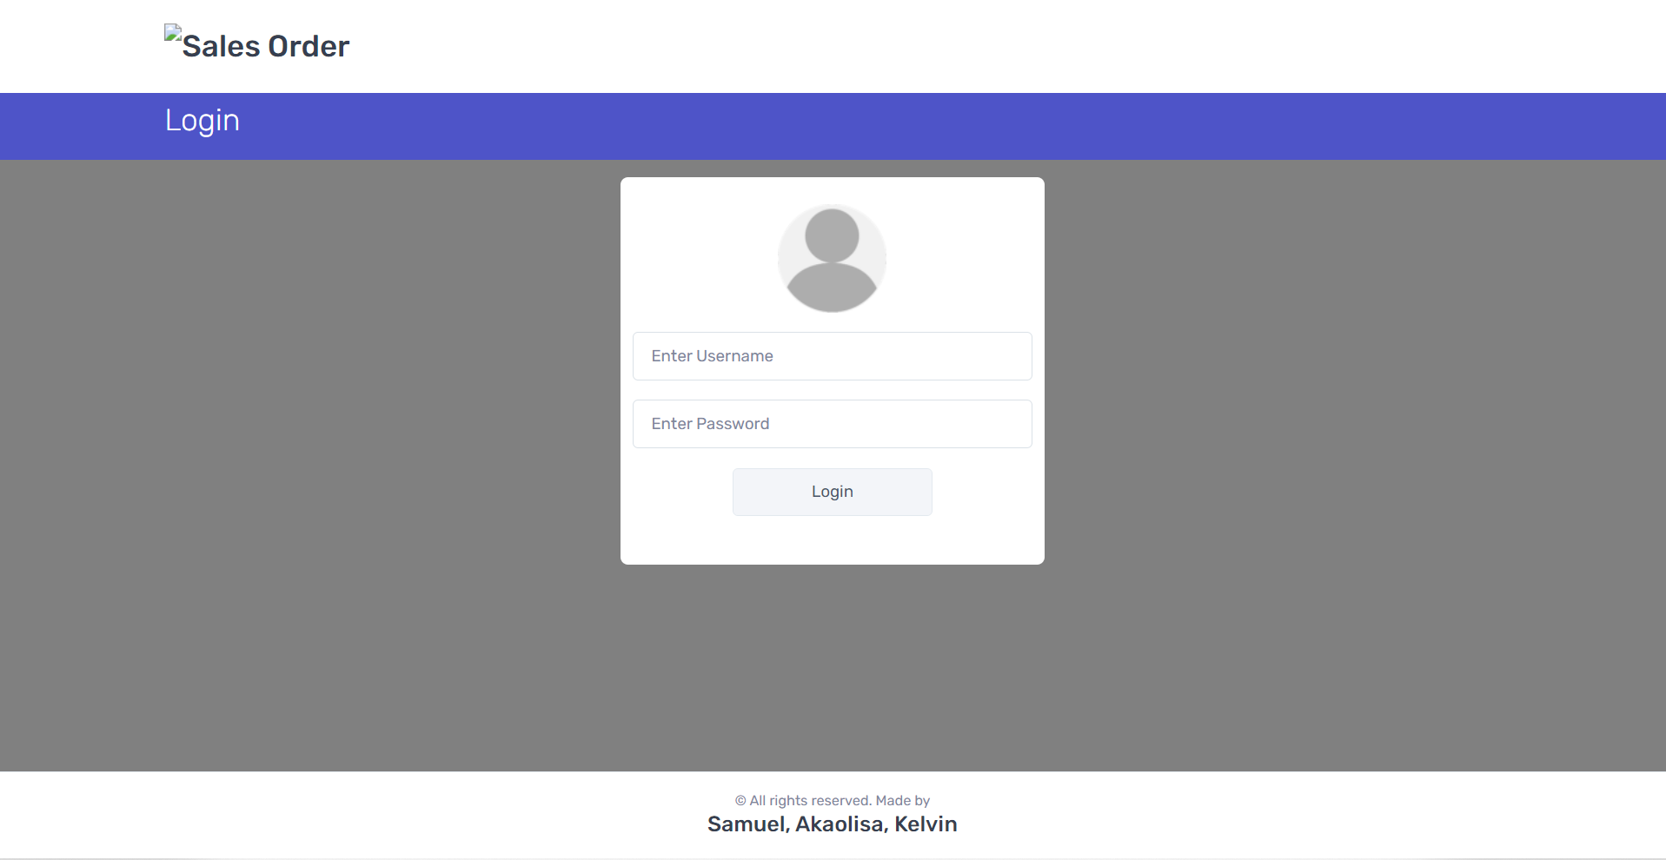**Figure 1** Login Page

1. **Dashboard**

Figure 2 shows the Sales view of the system with different sub modules in sales such as new item, new item, new customer, new department, new staff etc. The web application contains customer’s account details such as their name, address, name of the organization they are associated to, contact details etc.

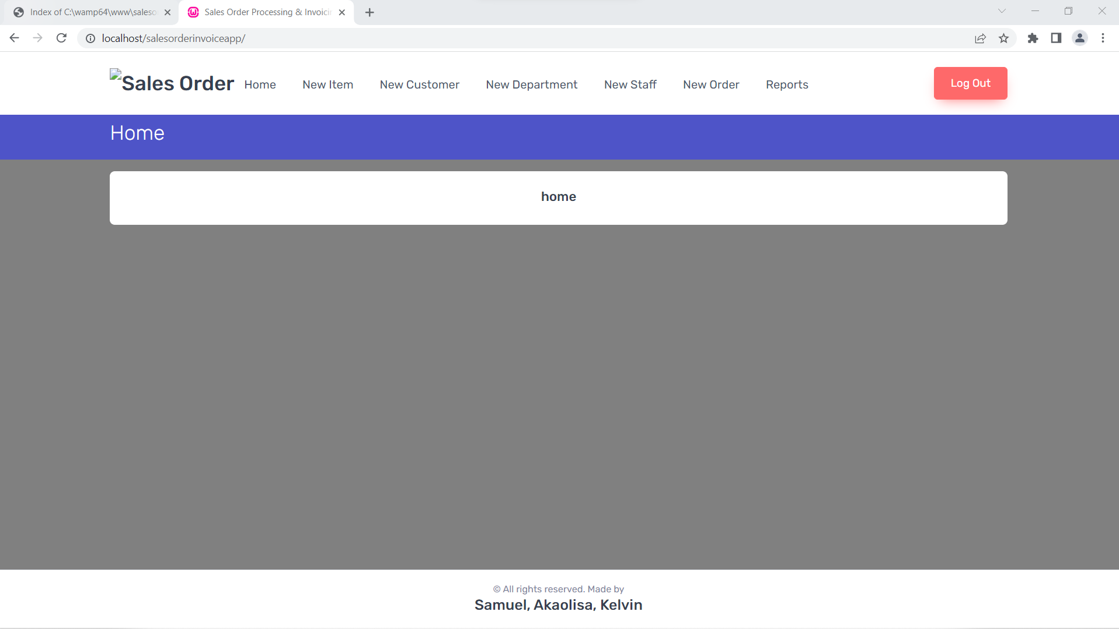

**Figure 2** Dashboard

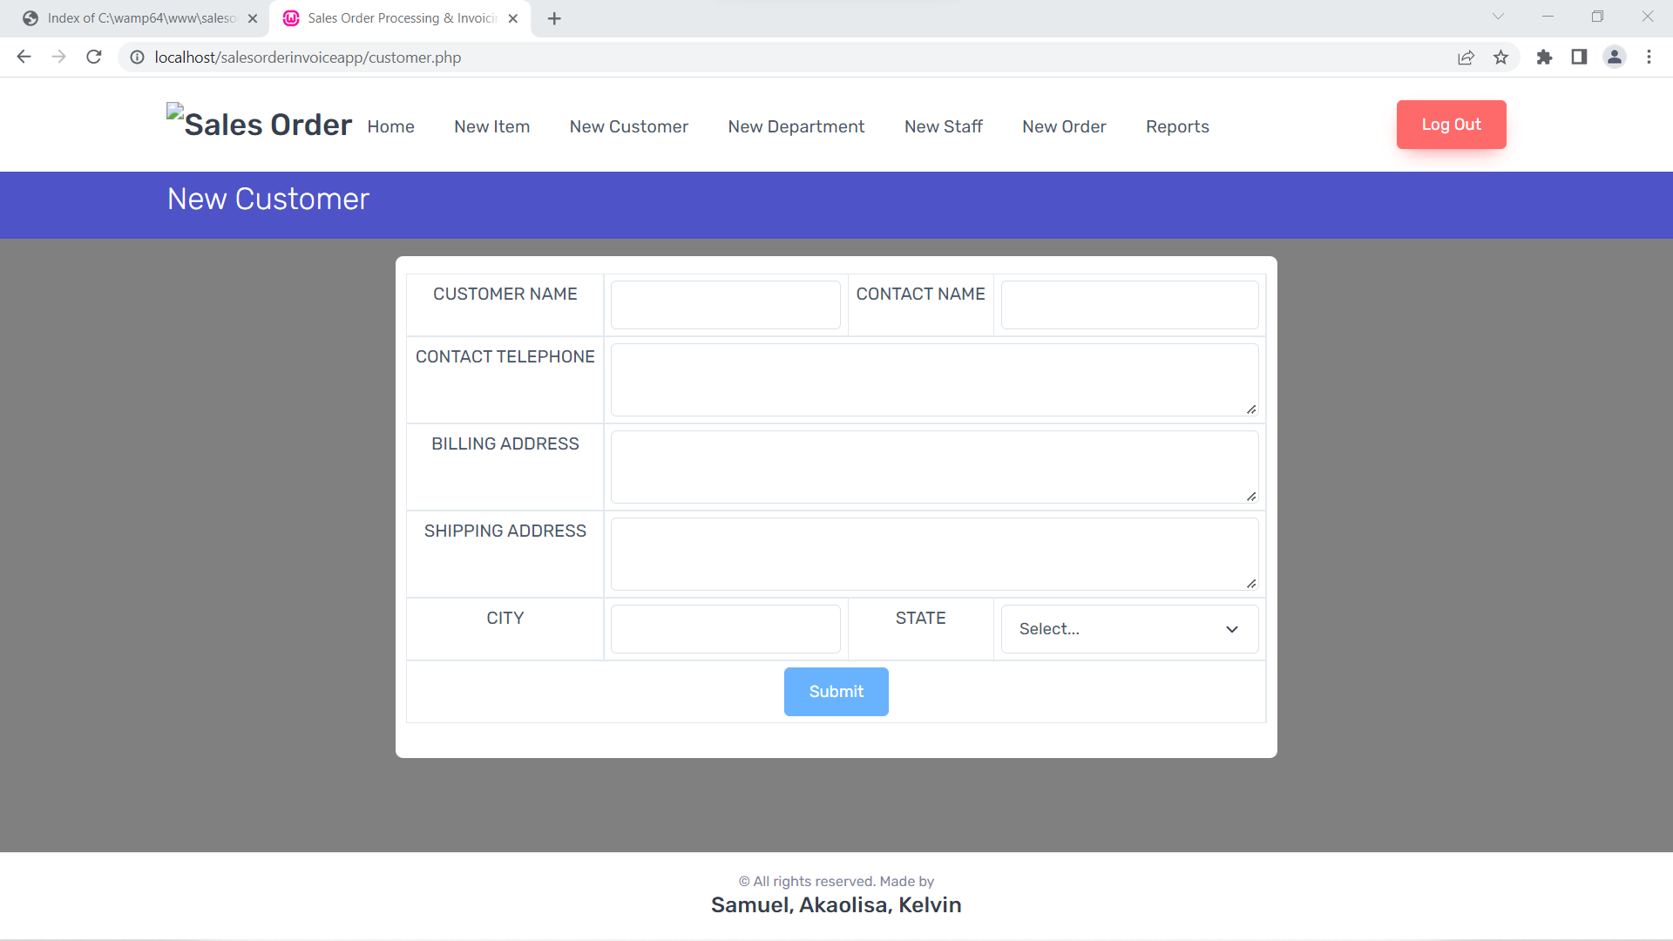

**Figure 3** Showing the addition of a new customer information and shipping information.

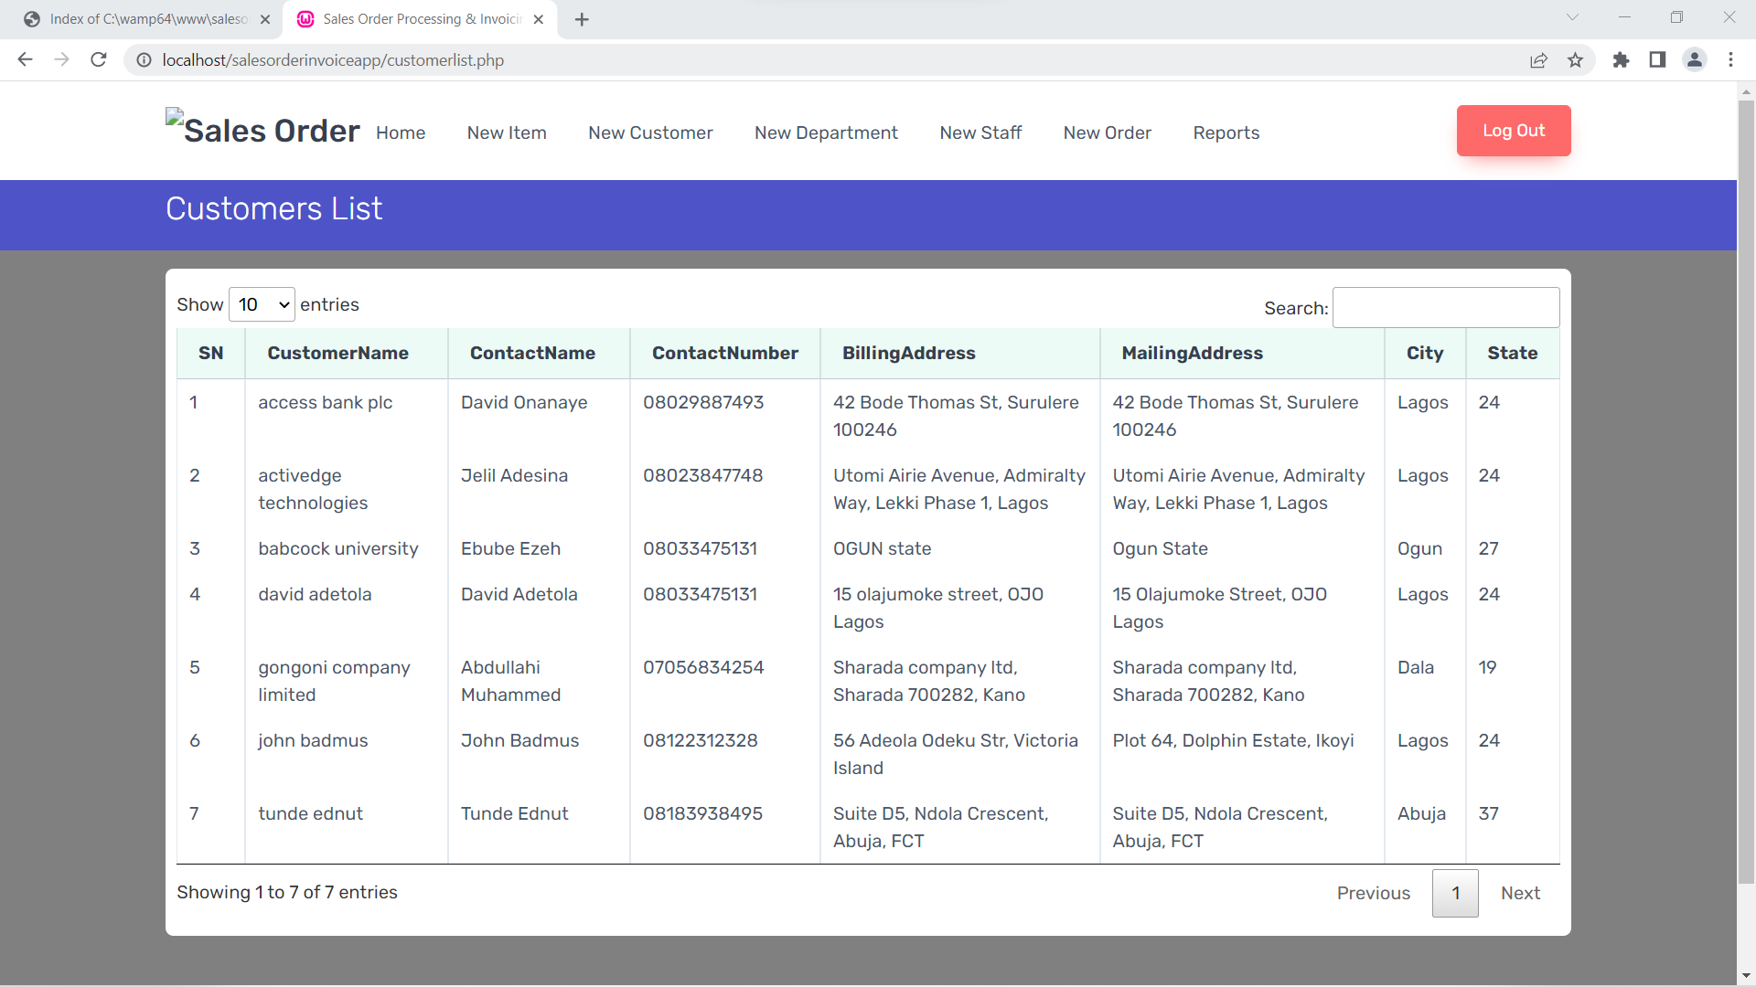**Figure 4** Showing the customer database.

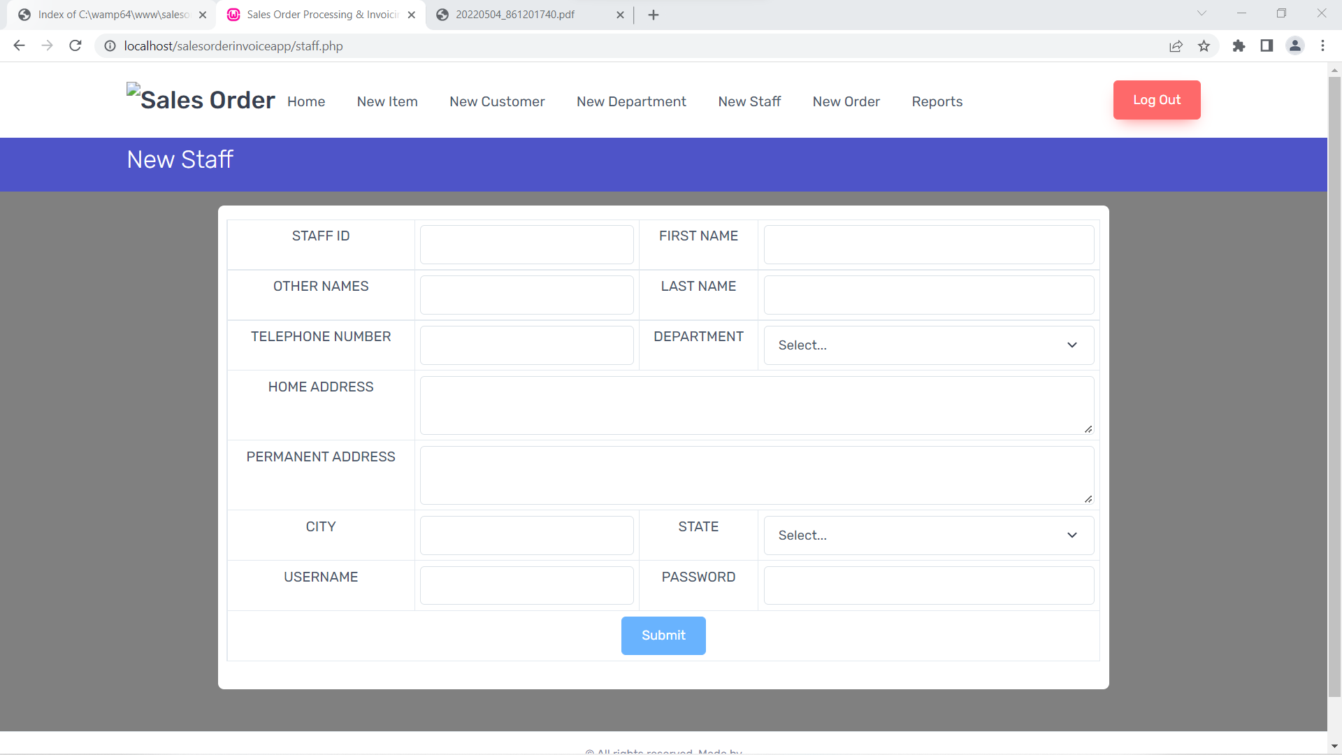

**Figure 5** Showing the addition of a new staff to the organization

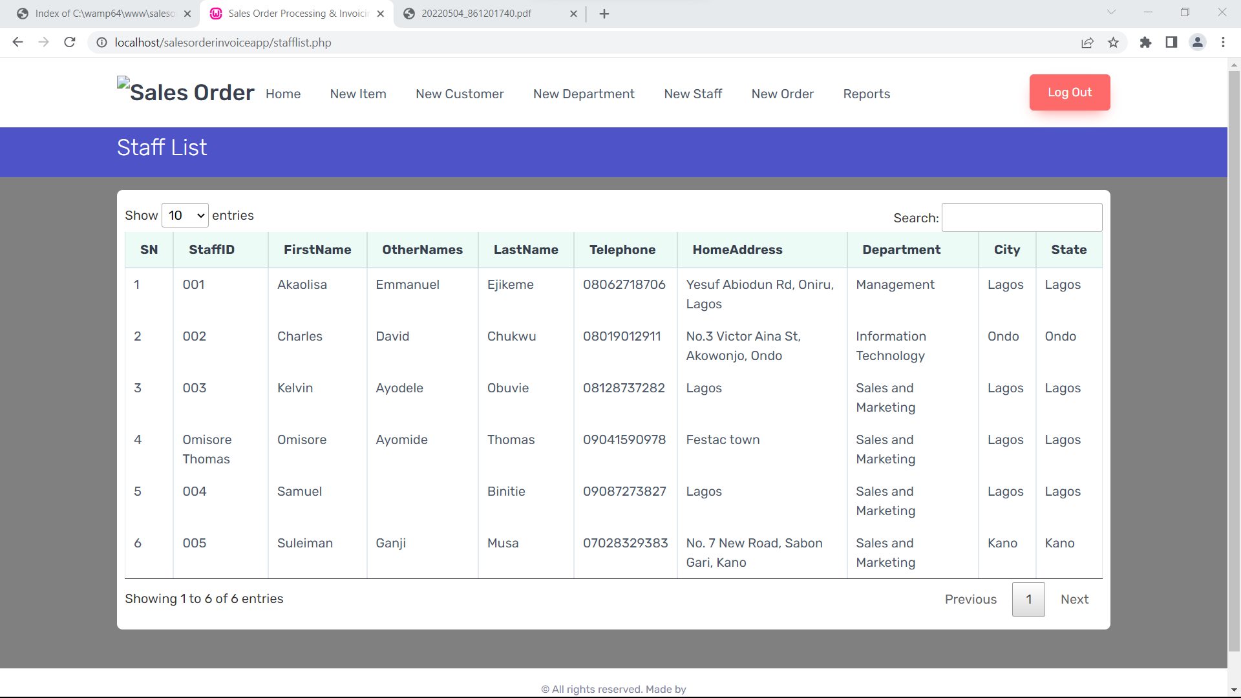

**Figure 6** Showing the list of staffs of the organization

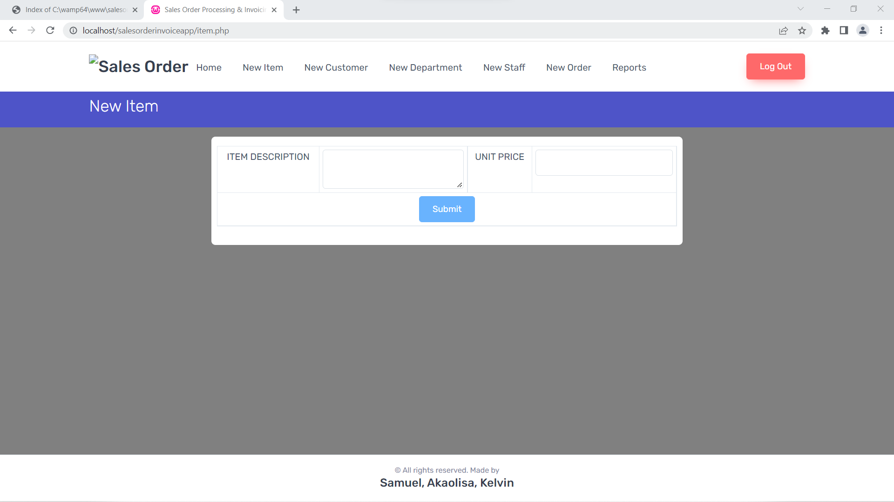

**Figure 7** Showing the addition of a new product into inventory.

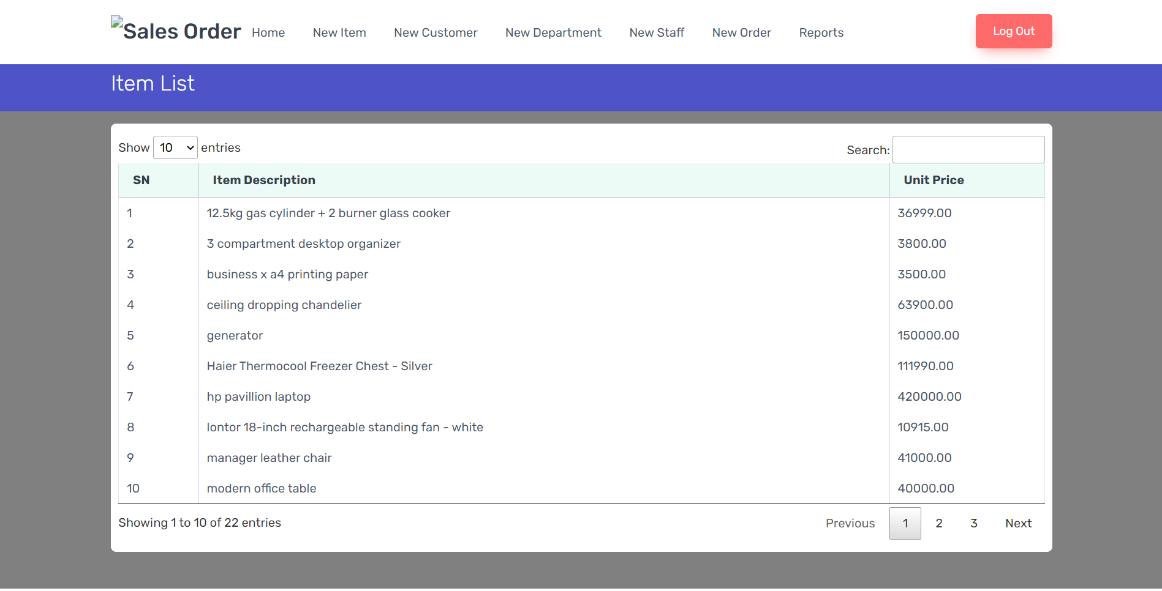

**Figure 8** Showing the products available in the inventory.

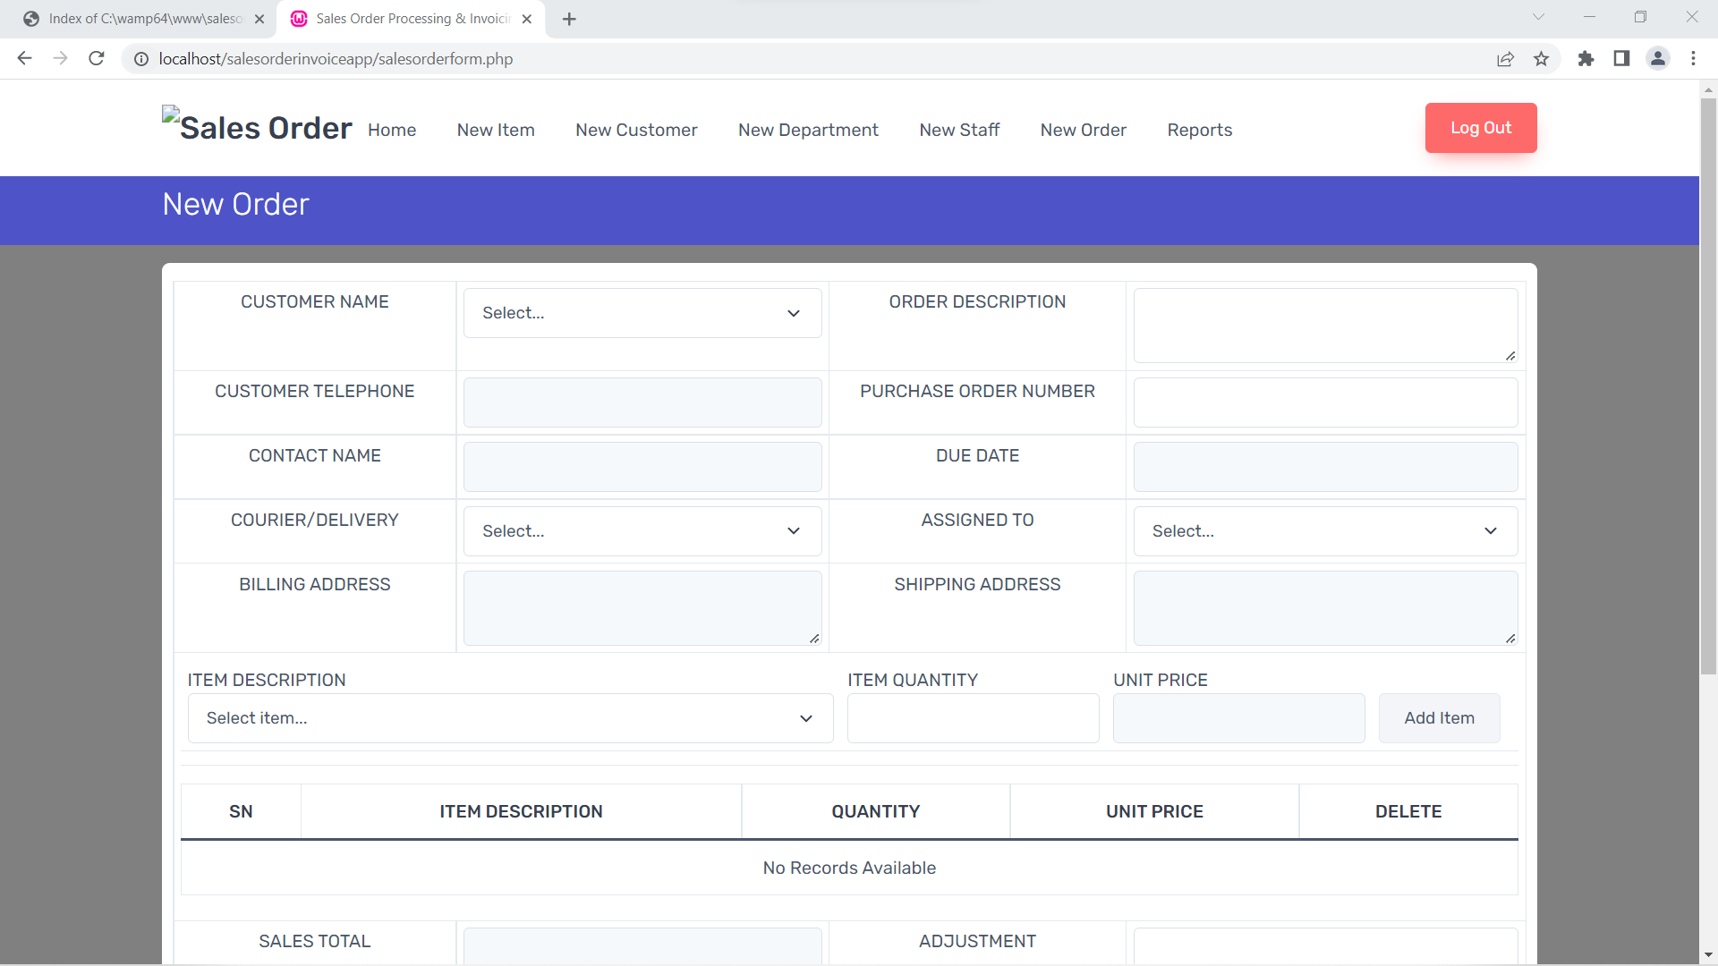

**Figure 9** Showing the generation of a new sales order for a customer.

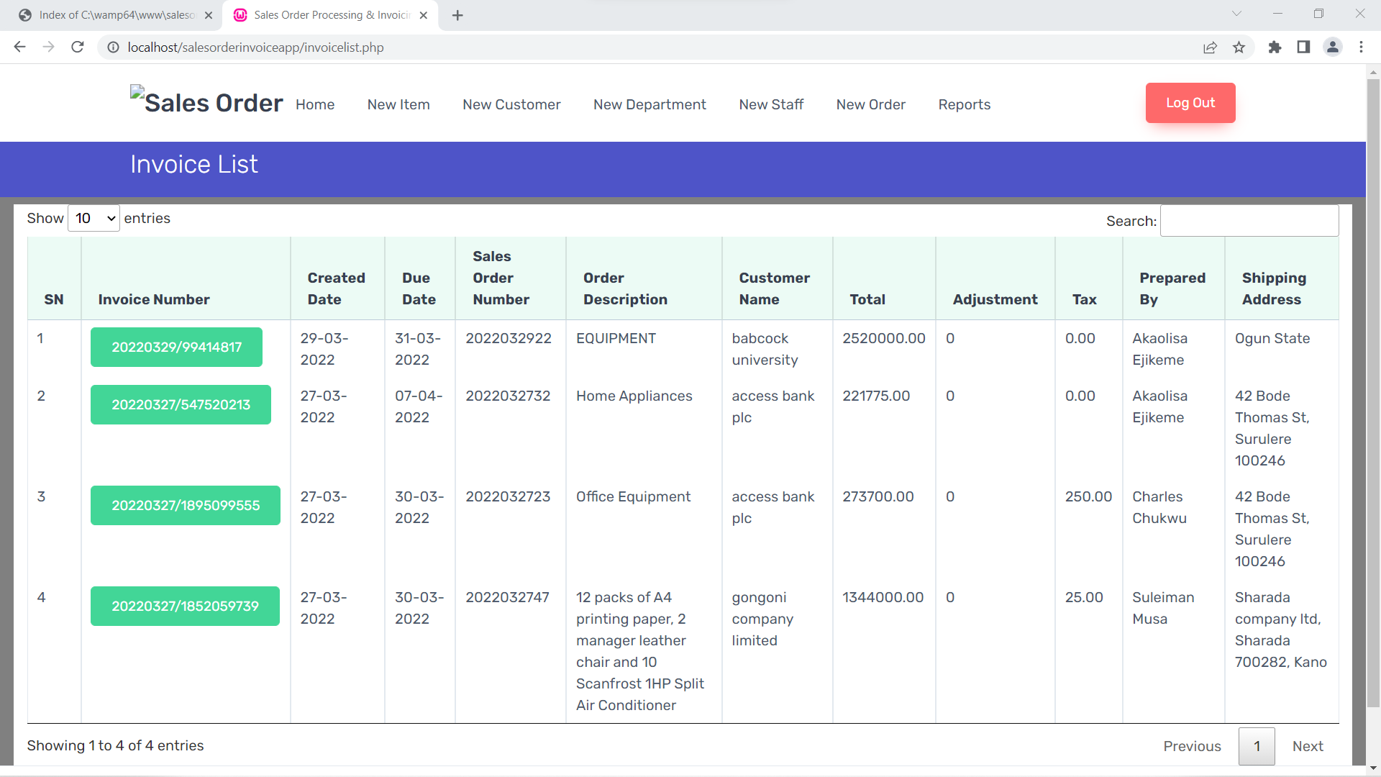

**Figure 10** Showing the database for invoices.

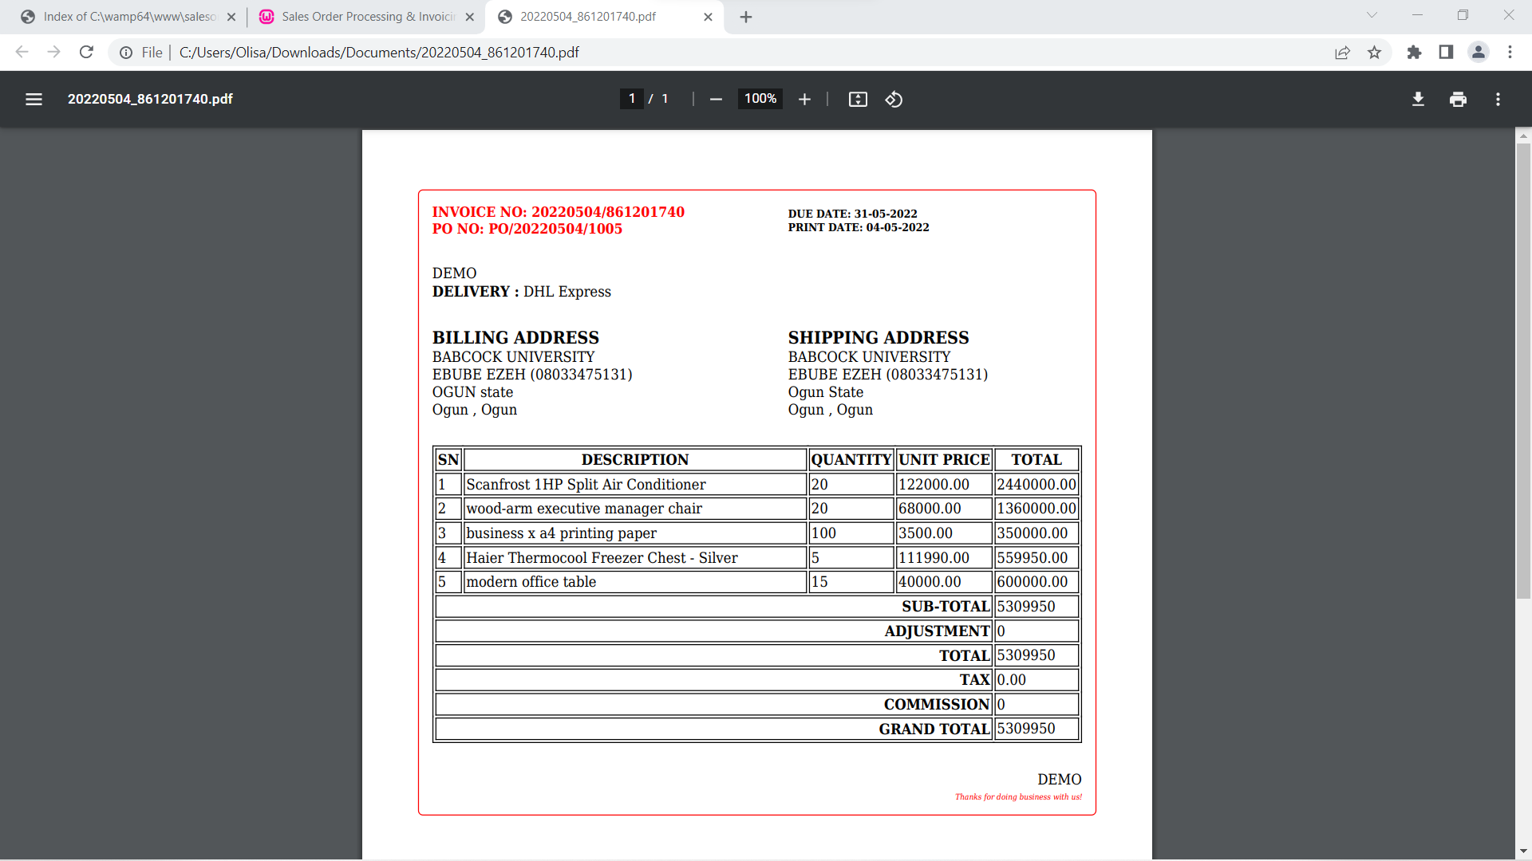

**Figure 11** Showing the pdf preview of an invoice for a customer